Kol Simcha Torah Gazette
For acharei mos-kedoshim 5786
Vol 10 Issue 28 (Whole #493) 8 Iyar 5786/ April 25, 2026
Printed L’illuy nishmas Nechama bas R’ Noach, a”h
For a free subscription, please forward your request to keren18@juno.com
Past emails can be found on the website ShabbosStories.com under Brooklyn Torah Gazette

If I Were Jewish
By Patrick Mascoe
A non-Jewish Canadian teacher asks the
questions every Jew struggles to answer.

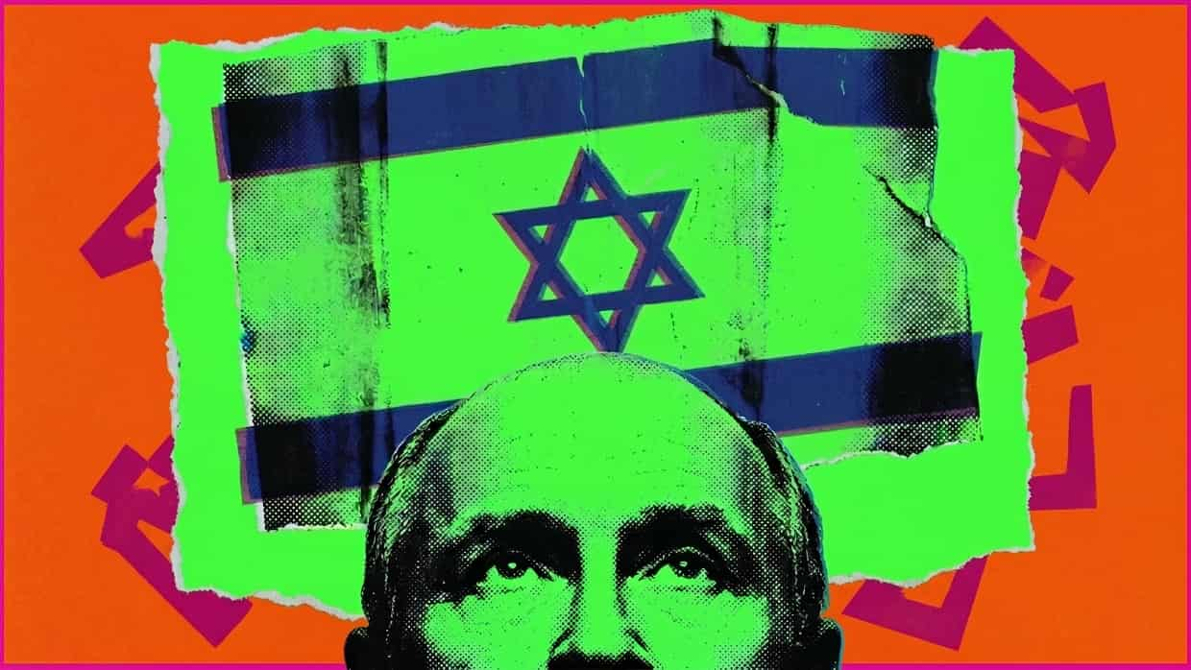

I’m not Jewish, but if I was, I think the first lesson I would teach my children is that life isn’t fair. How else can a Jewish parent explain to their children the injustice and discrimination they will be forced to face as they grow up? How else can parents answer questions that have no logical answer?
Why are Jews worldwide held responsible for the actions of the Israeli government? How come Jewish high school students living in Canada and the United States get blamed for the actions of Benjamin Netanyahu? No one blames Muslim students for the actions of Hamas or Boko Haram. As a matter of fact, after the terrorist attacks of September 11, 2001, politicians both in the United States and Canada advocated for the public not to stereotype or blame members of the Muslim community for the actions of the minority. Yet today, Jews are seen as universally homogeneous.
Why are Jews worldwide held responsible for the actions of the Israeli government?
Why does the term Zionist take on such a derogatory tone? People resent the idea of a Jewish state, but take no offense of Islamic Republics run under Sharia law. The Jewish State protects women’s rights and recognizes same sex partners, while non-Jews are granted the same legal rights as Jewish citizens. Islamic Republics treat women as chattel and homosexual behavior is punishable by death, while non-Muslims are treated as second-class-citizens. Despite the obvious imbalance of human rights, Islamic States face little criticism while Israel is constantly bombarded with condemnation.
Why is there only condemnation of the Jewish state? Public demonstrations against Israel are relentless. How come when Bashar al-Assad in Syria used chemical weapons against his own citizens no one took to the streets? Why aren’t there demonstrations in support of women’s rights in the Middle East? What about human rights in China?
Why do we hear the claim that Israel has no right to exist? Why is the only country on earth whose majority population just happens to be Jewish the only one being referred to as an illegitimate state? The reality is that Israel has existed for more than 75 years and is among the older half of all countries in the world. Countries either exist or they don’t exist. There is no such term in international law as an “illegitimate” state. So why is this used when describing the Jewish state and no other country?
In 1949, after Chiang Kai-Shek lost the Chinese civil war to Mao Zedong, he moved his government to Taipei. Mao Zedong declared that government an illegitimate entity, yet today Taiwan is universally recognized as a legitimate country. Pakistan was formed in 1947 as a result of Muslim separation from India. Bangladesh won its independence from Pakistan in 1971 through an armed conflict. These countries, even those established by violence - once established - become part of the international community and gain acceptance.
Why do people call Israel an apartheid state? How can you be an apartheid state when all your citizens have equal voting rights, freedom of movement, freedom of assembly, freedom of speech, freedom of religion, and freedom of the press? How does that resemble the apartheid of South Africa?
Why is Saudi Arabia not called an apartheid state? Freedom of religion does not exist. The government prohibits the private or public practice of any religion other than Islam. Freedom of speech and press are restricted. It has only been in the last ten years that women have been able to drive or vote in elections. So why is it Israel that gets labeled?
After the horrendous terrorist attack of October 7th where Israeli citizens were targeted, no one took to the streets to denounce such a barbaric act. But they did take to the streets and campuses to protest against Israel over a war that they did not start. Many of those same protestors readily acknowledge Ukraine's right to defend itself. But inexplicably deny Israel’s right to do the same.
If I were Jewish, I would wonder why so many people choose to ignore history. Not all history, just Jewish history. No one questions the Cambodian genocide, the Darfur genocide, or the Rwanda genocide. Yet, the largest and most historically documented genocide to ever take place is often up for debate as to whether it happened or not. Why is Holocaust denial even a thing? There is only one reason and that is because it happened to Jews.
Israel, a country historically inhabited by Jews is now being labelled as colonizers by pro-Palestinian supporters. Does this not strike people as ironic? The world’s one Jewish nation, with a population of seven million Jews, is being labelled as colonizers by the world’s two billion Muslims. The religion of Islam has colonized 52 countries, yet the Jews and their one country are colonizers. These facts are there for all to see. Sadly, people will believe a lie that is continually repeated and accept it as fact rather than ask questions and apply critical thinking.
When one country and one group of people are held to a higher standard than others, one must wonder why?
When one country and one group of people are held to a higher standard than others, one must wonder why? Everyone publicly agrees that racism and discrimination is wrong, yet antisemitism is systemic. How do you tell your children that a world preaching tolerance excludes them?

What I Would Tell My Jewish Child
If I was Jewish, perhaps this is what I would tell my child. Jews have been the designated scapegoat of civilization for two thousand years. Every era finds its own justification: religion, race, nationalism, now geopolitics. The packaging changes but the target doesn't. Antisemitism isn't a reaction to what Jews do. It's a pattern so deeply embedded in human history that most people who carry it don't even recognize it in themselves.
If I were a Jewish parent, I would tell my children that you belong to something remarkable, a tradition of wisdom and values that has outlasted every force that tried to extinguish it.
But here is what that history also shows: Every empire that tried to erase them is gone. The Egyptians who enslaved them, the Romans who exiled them, the regimes that built industries around their destruction. All of them are footnotes, but the Jews are still here.
That is not an accident. It is the result of a civilization that chose meaning over despair, memory over forgetting, and morality over convenience. A people who, in the aftermath of the worst atrocity in human history, built a thriving nation, won Nobel prizes, pioneered medicine and technology, and continued to ask the oldest Jewish question: how do we make the world better than we found it?
If I were a Jewish parent, I would tell my children that you belong to something remarkable, a tradition of wisdom and values that has outlasted every force that tried to extinguish it.
That is a legacy worth carrying with pride.

Reprinted from the current website of aish.com

******************************************************************
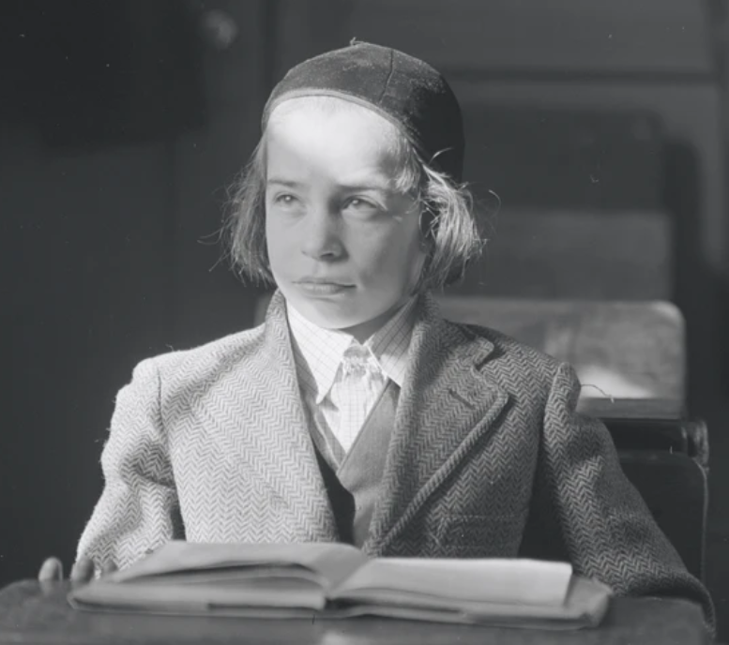
Photo by Morris Huberland (1909-20030 of a Jewish yeshiva student in the Lower East Side of Manhattan from the collection of The New York Public Library.
The Obligation of the High Priest to Assist His Fellow Jews Over His
Desire to Come Closer to G-d
Compiled by Mordechai Rubin
From the Teachings of the Lubavitcher Rebbe
Rabbi Menachem Mendel Schneerson, Zt”l
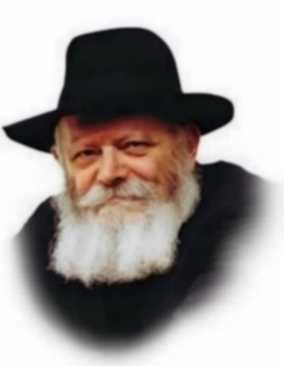
This week's Torah reading, Acharei, describes the sacrificial worship carried out in the Temple on Yom Kippur, but it prefaces that description with an allusion to the death of Aaron's sons, Nadab and Avihu.
Why did Nadab and Avihu die? The Torah relates previously that they entered the Holy of Holies with "a strange fire that G-d did not command them [to bring]."
Now on Yom Kippur, the High Priest would enter the same sacred place, the Holy of Holies. And so, the Torah warns him not to repeat the error made by Aaron's sons.
What was the mistake of Aaron's sons? They sought closeness to G-d and were willing to give up everything, even their lives, to achieve that. The Or HaChayim, one of the classic commentaries on the Torah, explains that their death did not come as a punishment. Instead, their souls appreciated the G-dly light manifest in the Holy of Holies and clung to it. Their desire for G-dliness was so great that their souls simply expired.

The Focus of the High Priest
is for Life in This World
This was the error that the High Priest was to avoid on Yom Kippur. Although he would enter the Holy of Holies and come face to face with the Divine Presence, he was warned to keep in focus that the intent of his service was life in this world, not a bond with G-d in the spiritual realms. Rather than seek out closeness with G-d, his purpose in entering was to evoke atonement and blessing for the Jewish people as they exist in this material realm.

The Obligation to Fulfill G-d’s Will
What is the core of the issue? Aaron's sons sought their own spiritual satisfaction; what was gratifying for them. The High Priest, on the other hand, is a servant, carrying out G-d's will, aware that what G-d desires is not a bond with Him in the spiritual realms, but rather the observance of His will and His mitzvot (commandments) in this material world.

The Desired State of Existence
Similar concepts apply with regard to the ultimate, desired state of existence. Maimonides maintains that the ultimate is the spiritual world of souls, the afterlife. All material existence, even the heights to be reached in the era of the Redemption and the era of the Resurrection, he maintains, is secondary to the G-dliness to be experienced when the soul leaves the body.
The Sages of the Kabala, the Jewish mystic tradition, differ and maintain that the ultimate state will be the Resurrection of the Dead. Souls that have enjoyed spiritual bliss in the afterlife for thousands of years will descend and live again in a material body. For G-d's essence is invested in this material world, and it is through life in this world that the most encompassing bond with Him can be established.

Reprinted from the Parshat Acharei Mos 5786 email of L’Chaim, a publication of the Lubavitch Youth Organization in Brooklyn, NY. Adapted from Keeping In Touch by Rabbi Eliyahu Touger, adapted from the teachings of the Rebbe

Rav Avigdor Miller on
Can a Frum Jew Celebrate
Israel’s Independence Day

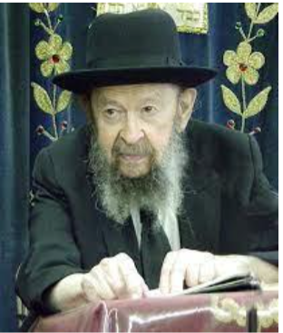

QUESTION: Would a person be allowed to celebrate the fifth of Iyar (Israeli Independence Day), the same way he celebrates the Fourth of July?
ANSWER: The answer is that the Fourth of July has no Jewish connotation; it’s a neutral thing. And since it’s a demonstration of loyalty to the county where you live, it certainly is virtuous to hang out a flag on the Fourth of July. I think that all Jews should be interested in demonstrating solidarity with the American people. And especially to thank Hakadosh Baruch Hu that there is such a country that fosters such ideals of liberty which Jews enjoy today.
The fifth of Iyar is a different story entirely. The Medinas Yisroel was founded by atheists. Of course, there was a small handful of maaminim also. But the vast majority were atheists, and they were extreme left-wing radicals.
So how can we demonstrate any kind of sympathy with a State that is diametrically opposed to the Torah?! The mere fact that they draft girls into the army is such a horrendous contradiction to Jewish tradition, to Jewish attitudes, that for that alone, every conscientious Jew should feel a tremendous hostility to the State of Israel.
Reprinted from the Tazria-Metzora 5786 edition of Toras Avigdor. (Transcribed from a classic Thursday night hashkafah lecture delivered by Rav Avigdor Miller in November 9, 1980.)
Thoughts that Count
for Our Parsha

He shall wear a holy linen coat. (Lev. 16:4)
The High Priest wore only linen garb in the Holy of Holies, rather than the gold clothing which he wore the entire year while performing his duties. This is because Israel built the golden calf, and even a reminder of that sin should not be brought into the Holy of Holies. (Tz'ena Ur'ena)

On the tenth day of the seventh month, you shall afflict yourselves. (Lev. 16:29).
The Apter Rav author of Ohev Yisrael used to say: "Were I only to have the authority I would annul all the fast days on the Jewish calendar with two exceptions. Those are the Ninth of Av, date of the destruction of the Temple - for who can eat on such a day - and Yom Kippur (the tenth day of the seventh month), the holiest day of the year - for who needs to eat on such a day?"

Because the life of all flesh is in the blood. (Lev. 17:11)
The blood is the "soul" of man and beast. G-d permitted us to eat only an animal's body, and not its soul. Since the blood of a beast is its soul, we do not want to take an animal's soul into our bodies. We must have an elevated consciousness in order to study Torah and perform mitzvot (commandments). That which a person eats turns to blood in his body and his mind is nourished from it. (Ramban)

Do not follow the ways of Egypt where you once lived, nor of Canaan, where I will be bringing you. Do not follow any of their customs. (Lev 18:3)
This verse is not exhorting us concerning transgressions; those are detailed later. Rather, it is informing us concerning the actions and deeds which are permitted; they must be performed in a different manner from the non-Jewish people in Egypt and Canaan. Even our eating and sleeping should be done in a Jewish way. (Siftei Emet)
Keep my decrees and laws, since it is only by keeping them that a man can truly live. (Lev. 18:5)
The Torah spells the word "otam" - them, without the usual vav, leaving only the letters of the word "emet" - truth. This indicates that if one makes truth the byword and mainstay of his life, he is guaranteed to see the fulfillment of the end of the verse, "He shall live by them." For clinging to truth is a special blessing for long life. (Degel Machane Efrayim)

Love your neighbor as yourself; I am G-d (Lev. 19:18)
Love of a fellow Jew is even greater than love of G-d. He who loves a Jew loves the one whom G-d loves, as it is written, " 'I love you,' says the L-rd." To love that which the beloved loves is even greater than loving the beloved himself. (Rabbi Schneur Zalman of Liadi)

Rabbi Levi Yitzchak of Berditchev, in the name of the Baal Shem Tov explained the Mishna, "All Torah-study not combined with work will in the end cease" (Fathers 2:2). He said that the word "work" implies that one must "work" at loving one's fellow Jew to ensure the endurance of one's Torah study. Simple love of another Jew is not enough, rather, it must be done in a way of actually working at and being occupied with loving another Jew.

Love of one's fellow-Jew will bring the final redemption as it states in the Midrash "Israel will not be redeemed until they are united." The reason for the present exile was unwarrented hatred. Only through unwarrented love - love even for those whom we've never, or in whom we see absolutely no redeeming quality - will the redemption come. (The Lubavitcher Rebbe)

You shall be holy because I am Holy. (Lev. 19:2)
The Midrash explains that these verses were said during the "Hakhel" years when all of the Jews were assembled together in Jerusalem. The fact that these words were said in public teaches us that even in the street, so to speak, one should be holy and not be ashamed of one's Jewishness. (Divrei Shaarei-Chaim)

You shall not stand [idly] by the blood of your neighbor. (Lev. 19:16)
In addition to a command concerning someone in physical danger, this verse is also an instruction for spiritual rescue. If one sees a Jew who is in danger of spiritual "drowning," it is forbidden to just stand there and watch. You must do all you can to help him. And, if you say, "Who am I to go out and save a soul?" the very fact that you are aware that the other person needs help and is in danger is proof that you have the ability to save him. (Likutei Sichot)

Reprinted from the Parshat Acharei Mot 5763/2003 and Parashat Kedoshim 5763/2003 editions of L’Chaim, a publication of the Lubavitch Youth Organization in Brooklyn, NY.
Rabbi Isaiah Halevi
Horowitz (The Sheloh)
By Nissan Mindel

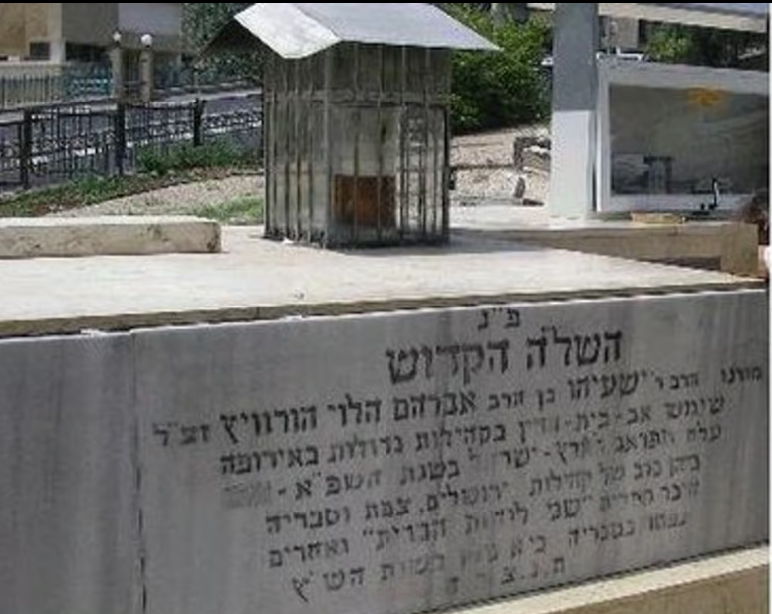
The Kever (burial place) of The Sheloh (1558/5318 – 1628/15580

Rabbi Isaiah Halevi Horowitz was born in the well-known city of Prague, in the year 5318 (1558) , just over 400 years ago. His father, Rabbi Abraham bar Rabbi Shabse Sheftel Halevi, was a celebrated Gaon and author of many works (Yesh Nochlin, Emek Brochoh, Chesed Avrohom, Bris Avrohom). He was the first teacher of Rabbi Isaiah. Later on, the father, with his whole family, left Prague, and went to Cracow in Poland, and from there to Lublin, where Rabbi Isaiah studied at the celebrated Yeshivoh of the Maharani. He married the daughter of one of the leading members of the Vienna community, Reb Avrohom Moul. His wife's name was Chaye.
Rabbi Isaiah Halevi Horowitz is famous as the "Sheloh Hakodosh" (the saintly Shelo) because of his great work, Shnei Luehos Habris (SheLoH). At an early age, he was recognized as a great Gaon, and he took part in the meetings of the Rabbis of the Vaad Arba HaArotzos (Council of the Four Countries), together with the greatest Rabbis of his generation. He held Rabbinical positions in various communities such as Dubno, Ostraha, Posen, Cracow, Vienna and Frankfurt, where he headed great Yehsivos and had large numbers of students.
When the Jews were driven out of Frankfurt in the year 5375 (1615) on the 27th of Elul, Rabbi Isaiah went with them into exile. Later on, he was chosen as Chief Rabbi of his native Prague, a position he occupied for seven years. At first, he shared the office together with the great Rabbi Efraim Luntschitz (author of "Olelos Efraim"), and upon Rabbi Efraim's death (7th Iyar, 5379 [1619]), the Shelo remained the sole Chief Rabbi in Prague, where he stayed until he left for Eretz Yisroel in the year 5381 (1621) .
He always felt a desire to live in the Holy Land, and when his wife died in 5380 (1620) , he decided to satisfy his longing for the Holy Land, and he went there. He left his comfortable position, bade farewell to his children and grandchildren, and set out on the long journey. It was especially difficult for him to leave his dear son, Rabbi Sheftel, who was already a Gaon himself. Rabbi Isaiah stopped at Venice and other places on the way, where he was welcomed with great honor.
On Friday, the 6th of Kislev, in the year 5382 (end of 1621) , the saintly Sheloh arrived in the holy city of Jerusalem. The Ashkenazic community immediately appointed him as their Rabbi.
Here in the Holy Land, he arranged his Siddur (Prayer Book) "Shaar Hashomayim" (the Gate of Heaven). He gave it this title because numerically the word "Hashomayim" equals the word Isaiah (395), and also because he arrived in Jerusalem on Friday, when the Portion of the Week to be read in the Torah was Vayetze, which contains the words "Vezeh Shaar Hashomayim," that our father Jacob said upon awaking from his heavenly dream. The Siddur was printed by his great-grandson, Rabbi Abraham in the year 5477 (1717), with the Haskomoh (written approval) of the Bach, Tosefos Yom Tov, and other great Rabbis of the period.
Two years after his arrival in Eretz Yisroel, he finished his gigantic Shnei Luchos Habris ("Two Tablets of the Covenant") known by all as the "Sheloh Hakodosh."
The year of the Sheloh's settling in Jerusalem was a Shemittah year (Sabbatical year). Because the previous year had been a year of drought and hunger, people sought to be a little lenient in the observation of the Shemittah. The Sheloh, however, did not agree to any leniency, in spite of the difficulty of the situation.
During the early part of his stay in Jerusalem, the governor of the city was Mahmoud Pasha, an honest and friendly ruler, and the position of the Jews was not such a severe one. But in the year 5385 (1625) , a rich Arab from Jerusalem (his name was Ibn Farouk) bribed the Governor in Damascus, and bought the ruling powers over Jerusalem. He was blind in one eye, and a wicked, cruel man. During the last Shabbos of the month of Teves, he entered the city with 300 armed soldiers, and took over the rule. He started to persecute the Jews, and sought all means of squeezing money out of them.
On Shabbos, the 11th of Elul, he sent his soldiers into the two Synagogues of the Ashkenazim and the Sefardim, and arrested 15 Rabbis, amongst them the Sheloh. He placed a huge ransom on their heads. They remained in prison until Rosh Hashonoh, when they were released after superhuman efforts by the community and a large amount of ransom money.
No longer sure of their lives, Rabbi Isaiah, together with other Ashkenazim, escaped from Jerusalem, and went to Tzefas (Safed) in the month of Teves. Later on, the Sheloh settled in Tiberias, where he finally ended his gigantic and magnificent work, the "Shnei Luchos Habris," which he sent to his children in Prague. Three years later, he died at the age of 70.
Before he departed for the Eternal World, he ordered that as soon as he dies, the following announcement should be made in all the Synagogues and Study Halls (Botei Midrash) in Tiberias and Tzefas:
"Friends! Let it be known that Rabbi Isaiah Halevi Segal Horowitz has died, and he ordered that no Hespedim (Eulogies) should be held in his honor. Special prayers should be offered during the first seven days and on the Yahrzeit." The grave of the saintly Sheloh is situated near the graves of Rabbi Jochanan ben Zakkai and the Rambam in Tiberias.
The Shnei Luchos Habris was written by him for his children and grandchildren. His son, Rabbi Shabse, better known as Rabbi Sheftel, who was the Chief Rabbi of Posen and vicinity, first published the Sheloh in 5408 (1648) in Amsterdam, adding his own work "Vovei Ho-Amudim." Fifty years later, in the year 5458 (1698-the year that the Baal Shem Tov was born) the Sheloh Hakodosh was printed a second time in Amsterdam in clear letters, and was in great demand. It is a highly respected and beloved work, and has been reprinted many times.
Tzefas and Tiberias were the centers of the study of Kabbalah that was taught by the saintly Ari and his disciple Rabbi Chaim Vital. Rabbi Joseph Karo (author of "Beth Joseph" and Shulchan Aruch"), was also one of the great and illustrious Kabbalists of Tzefas.
Also, the saintly Sheloh spent much time in the study of Kabboloh, which formed the basis for his great book. The Sheloh contains explanations and commentaries on the deeper aspects of Torah and Mitzvos, the Holidays and other facets of Jewish life. The book is filled with the spirit of holiness and piety, the love and fear of G=d, love of the Torah and love of the Jews. The author rightfully earned the title of "Sheloh Hakodosh," because he was a saintly person, and his teachings were saintly.
Besides the "Sheloh Hakodosh", and the Siddur "Shaar Hashomayim", with explanations of the Prayers, Rabbi Isaiah also composed other works, including Sefer Mitzvos and Tefillin. The Sheloh Hakodosh who traveled a lot, and occupied many Rabbinical positions, wielded tremendous influence, both personally and through his many thousands of disciples, whom he set up, and also thorough his great written work, the Sheloh (Shnei Luchos Habris), by which name he is known to the present day.

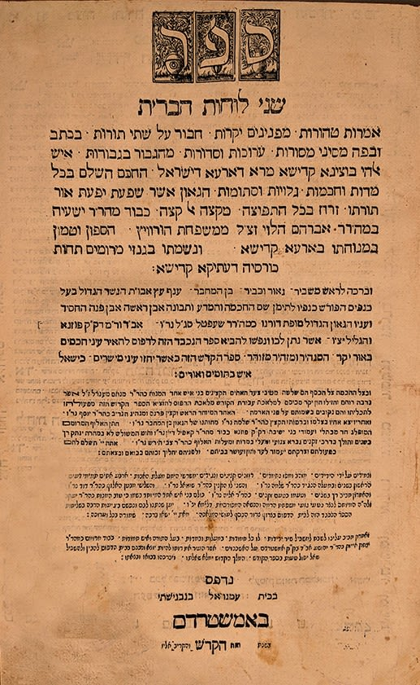
Title Page of the Shnei Luchos Habris.

Reprinted from the Parshat Acharei-Mot 5786 email of R’ Yedidye Hirtenfeld’s whY I Matter parsha sheet of the Young Israel of Midwood in Brooklyn. Reprinted with permission from the Kehot Publication Society.
The Month of Iyar: Light, Growth, and Healing
By Tzuriel Gvizon

Iyar, named after a Babylonian word meaning “light,” is a month of growth and meaning in the Jewish calendar. Explore what makes this month unique and why it holds special significance.
The Hebrew calendar is more than a way of marking time. Each month carries its own character, history, and spiritual meaning. The month of Iyar, which follows Nisan, is closely associated with growth, renewal, and healing, both in the natural world and in Jewish tradition.
Where Iyar Falls in the Hebrew Calendar
Iyar is the eighth month in the Hebrew calendar when counting from Tishrei, and the second month when counting from Nisan. This dual numbering reflects the Torah’s two ways of counting months one connected to creation and the other to the Exodus from Egypt.
The Length of the Month
According to the fixed Hebrew calendar, Iyar always has 29 days. It is considered a deficient month, meaning it never contains a thirtieth day.
The Origin of the Name Iyar
Like the names of most Hebrew months, the name Iyar comes from the period of the Babylonian exile. It is derived from the Akkadian word āyāru, which means light, reflecting the increasing brightness of the season.
Iyar and the Zodiac
The zodiac sign associated with Iyar is Taurus. This matches the natural cycle of the month, when fields are full of fresh grass and cattle are released to graze after the winter. The imagery of strength, stability, and growth fits well with this time of year.
Biblical Names and Agricultural Meaning
In the Bible, Iyar is also called Yerach Ziv, a name connected to the glow or radiance of the sun during this season. In ancient times, messengers would travel from Jerusalem to announce the new month, due to the importance of Pesach Sheni, the second Passover.
Another explanation of the word Ziv understands it as meaning bud, referring to the flowering plants that appear in the fields. Supporting this agricultural connection, an ancient Hebrew calendar discovered in Gezer, dating to the tenth century BCE, refers to Iyar as the month of the barley harvest.
Historical Events in the Month of Iyar
Several significant events in Jewish history are traditionally associated with this month. On the 2nd of Iyar, King Solomon began building the Holy Temple. On the 7th of Iyar, the walls of Jerusalem were inaugurated during the time of Ezra and Nehemiah. The 18th of Iyar marks the passing of Rabbi Shimon bar Yochai, and the 28th of Iyar marks the passing of the Prophet Samuel.
Jewish Observances During Iyar
Iyar includes several important observances. On the 14th of Iyar, Jews observe Pesach Sheni, the second Passover, which allowed those who were unable to bring the Paschal offering at the proper time to do so later. On the 18th of Iyar, Lag B’Omer is celebrated. The entire month of Iyar also falls within the counting of the Omer, a period of spiritual refinement between Passover and Shavuot.
Iyar as a Month of Healing
Many sources associate Iyar with healing. According to tradition, this is the month when the manna first began to fall in the desert. The manna, often described as the bread of angels, caused no illness and provided perfect nourishment, leading to the belief that Iyar holds special healing potential.
“I Am Hashem, Your Healer”
This idea is further reflected in an acronym formed from the Hebrew letters of the name Iyar: Ani Hashem Rofecha, meaning I am Hashem, your Healer. Because of this, Iyar is often viewed as a month suited for physical and spiritual healing, growth, and renewed strength.
The Message of Iyar
Iyar stands between redemption and revelation, between Passover and Shavuot. It is a month that teaches patience, steady growth, and trust in the healing process, reminding us that transformation often happens gradually, step by step.

Reprinted from the current website of Hidabroot.com

